Information resource for 

Wells Fargo Credit Connect -Paperless

Quick Reference Guide

Submitting a PAPERLESS application and PAPERLESS transaction

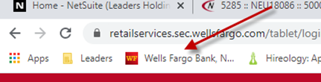

Sign into your Tablet or Computer

**For Computers:**

[:](http://www.wellsfargo.com/creditconnect)

[a](http://www.wellsfargo.com/creditconnect)

**For Tablets**:

.From any Web Browser:wellsfargo.com/creditconnect

For both Tablet and Computer access use the Username and Password designated for your store location.

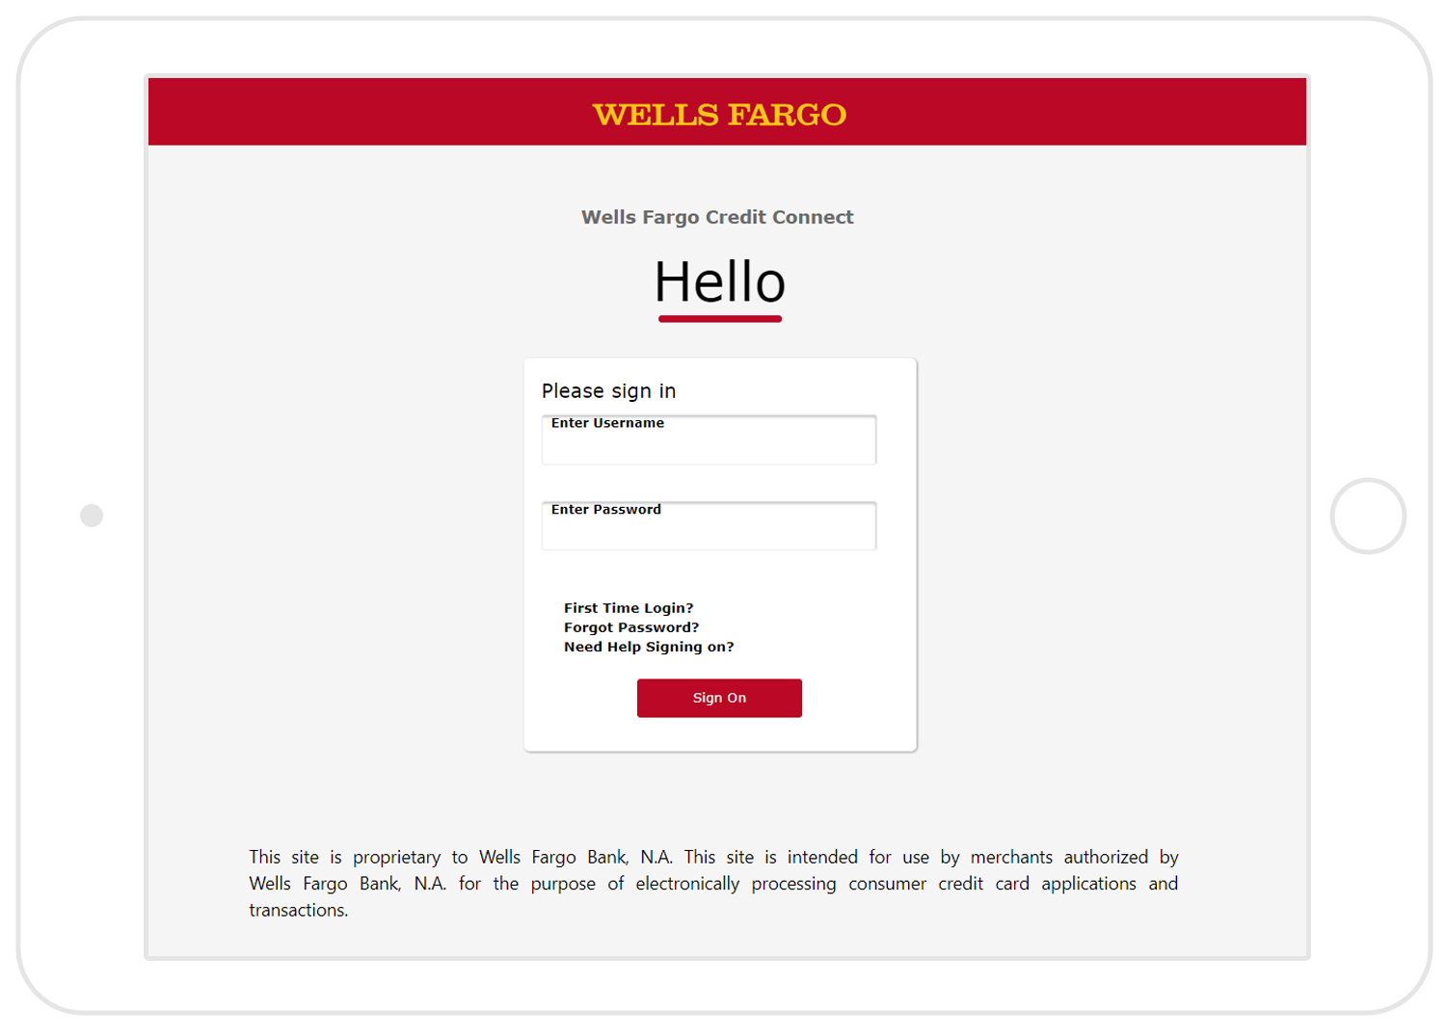

|  |  |  |
| --- | --- | --- |
| **Important Considerations:**   * To accommodate any customer situation, you must have both the paperless and paper-based credit card documents and equipment readily available. * In situations where the applicant can’t provide an email address, doesn’t have one, isn’t comfortable using your device, or doesn’t want to provide an electronic signature, you must use the paper application and/or invoice process. * When using the paper-based application, it’s critical that you have the customer complete the entire application and ensure they receive their paper terms and conditions. * To submit a paper-based application for a credit decision, sign on to the Online Resource Center at [wellsfargo.com/ retailservices](http://www.wellsfargo.com/retailservices). Bookmark this URL with a name like “Paper Process” for quick access. |  | All 3 requirements must be met in order to use Wells Fargo  Credit Connect  The applicant must be comfortable using your device.  1.   1. The applicant must provide their own valid email address. 2. The applicant must consent to electronic disclosures and provide an electronic signature. |

© 2019 Wells Fargo Bank, N.A. All rights reserved.

# Submitting an Application

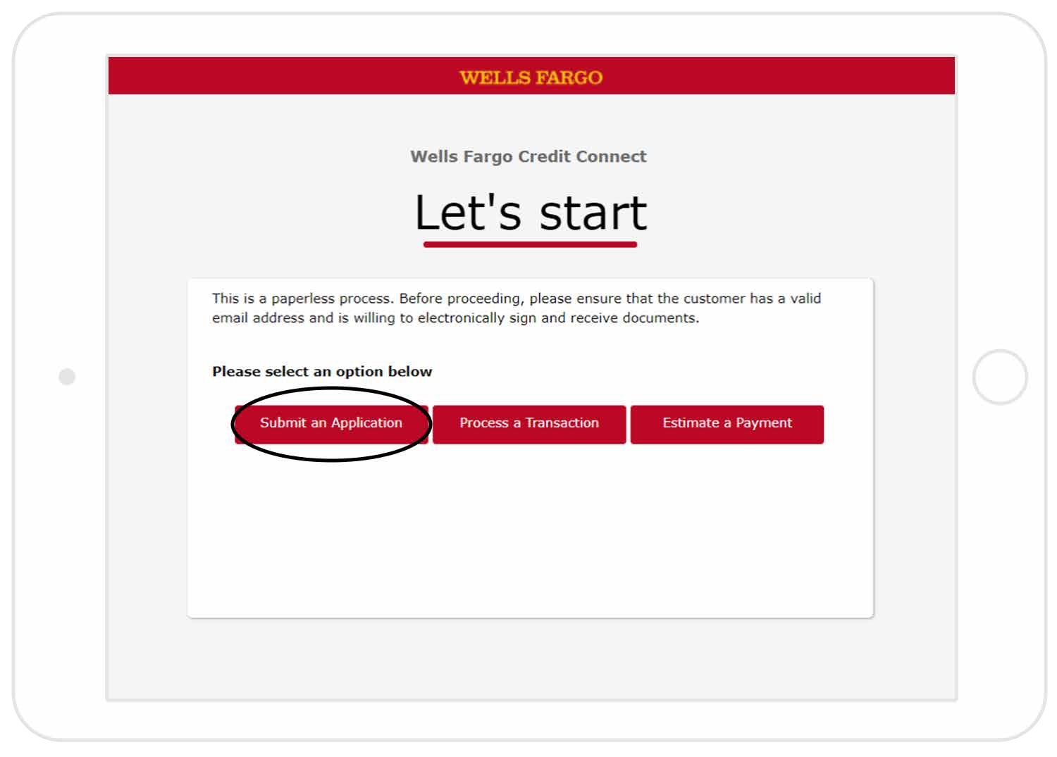**Follow all instructions at the top of the screen** Instructions will indicate who is to complete and/or review the screen.

For Practice customer data – refer to “Internet Process System (IPS) document.

1. Select “Submit an Application”
2. Select “Continue” to apply for a Wells Fargo credit card issued by Wells Fargo Bank,N.A.
3. Enter a Salesperson ID and Estimated Purchase Price if applicable, select “Continue”
4. Turn the device over to the customer as they will select “Continue” to apply for a Wells Fargo credit card issued by Wells Fargo Bank,N.A.
5. The customer must agree to the electronic agreement and disclosures
6. The customer must enter their own valid personal email address
7. The customer indicates if there is a co-applicant
8. The customer must enter all of their required information
9. The customer must review all of the information to make sure it was entered correctly
10. The customer must provide an electronic signature that acknowledges they read and agreed to the terms of the Credit Card Agreement
11. Verify the applicant’s identity before continuing- with a photo DL or other Government Photo ID.
12. Communicate the credit decision displayed to the customer
13. You may immediately process a transaction on approved applications by selecting “Authorize Only”. Never select “Authorize and Charge”

# Authorize Only

Lets you reserve a portion of the available credit line until the product or service is received by the cardholder.

## Follow these steps for submitting an “Authorization for Future Delivery” transaction from the “Application Approved” screen

1. Select “Authorize Only”
2. Enter the amount, plan number, Sales Order number and Salesperson ID , then select “Continue” ( Plan # for 12 months is 1015; Plan # for 36 months is 4032)
3. Review authorization for future delivery details to confirm information was entered correctly.
4. The cardholder must consent to the authorization and verify all information is correct including their email.
5. A copy of the authorization transaction will be emailed to the cardholder
6. The Salesperson will note the Authorization code displayed- and enter it into the Netsuite Sales Order in the “Wells Fargo Approval Code” box.

# Process a Transaction

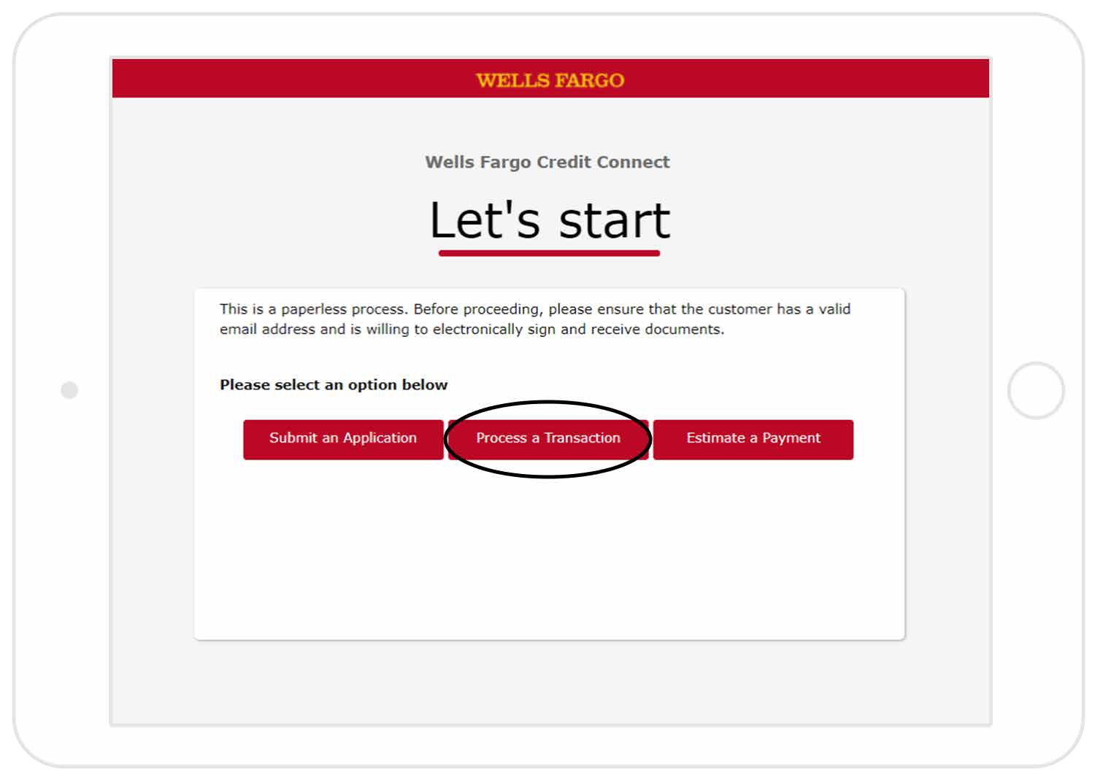You may process a transaction on any existing open, active account by looking up the cardholder’s account.

1. Look up the cardholder account by entering their 16 digit account number or entering 3 of the 7 cardholder criteria.
2. Choose the desired transaction -“Authorize Only” -reserves a portion of the available credit line until the product or service is received by the cardholder. Never use “Authorize and Charge” or “Credit/Return”.
3. Follow the remaining steps to process the transaction.
4. The cardholder will be emailed a copy of the receipt and will include the cardholders’ terms.

# Estimate a payment

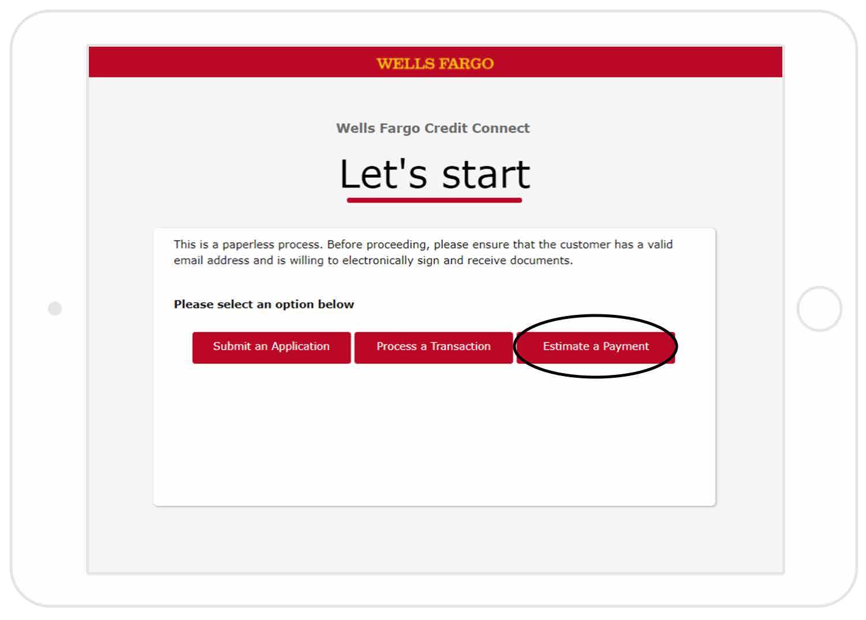The ability to calculate a payment by using multiple finance amounts and promotions with an opportunity to save, print or email to your customer.

1. Enter the customer name
2. Give each estimate a title to differentiate between them
3. Enter estimate information including amount to finance and four-digit plan code
4. Enter Merchant information
5. Select “calculate Payment
6. Use radio buttons to go back and forth between options
7. 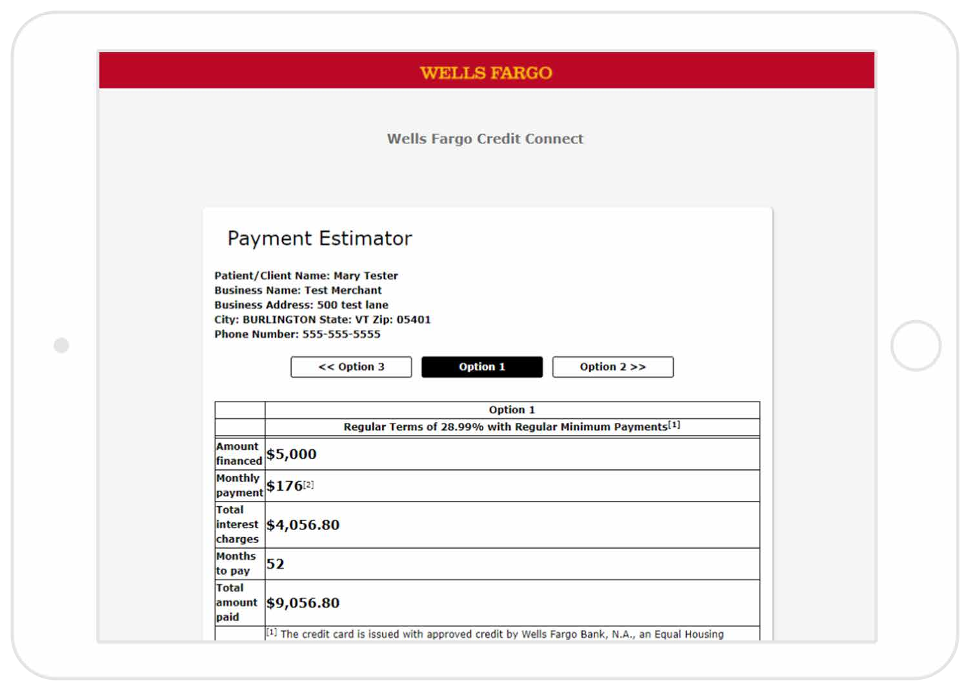Select “View PDF” at the bottom

of the screen in order to bring up a

printable document with proper

disclosures.

Tablets may not have printing

capabilities in all store locations.